EXPERIMENT-03
Aim: Understanding Android Components. Create and Android application with multiple activities. Implement the life cycle methods of each activity and observe their execution.
Theory:
Steps to Create the Project :
- Create Project
  - Open Android Studio
  - Click New Project → Empty Views Activity
● Name it: Practical_3_156
- Design Layouts
  - activity_main.xml → Add "Next" button
● activity_second.xml → Add:
○ Username (EditText)
○ Password (EditText)
○ Login button
  - activity_welcome.xml → Add TextView
- Add Activities
  - Right-click package → New → Activity → Empty Views Activity
● Create:
    - SecondActivity
○ WelcomeActivity
- Implement Code
  - MainActivity
    - Use Intent to open SecondActivity
  - SecondActivity
    - Get username & password from EditText
○ Validate inputs (if empty → show Toast)
○ Pass username using putExtra()
  - WelcomeActivity
    - Retrieve username using getStringExtra()
○ Display: "Welcome, [username]!"
- Check Manifest
  - Ensure all activities are added in AndroidManifest.xml

- Run App
  - Click Run
  - Test navigation and input

Code:
activity_main.xml
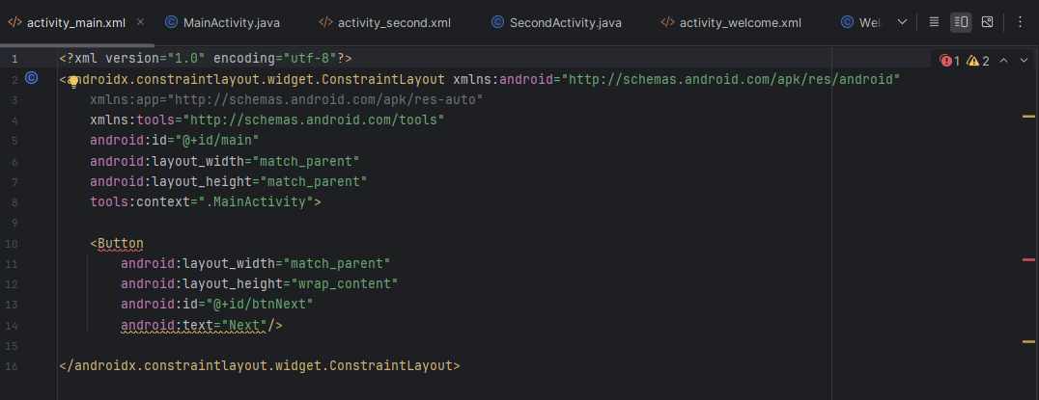

MainActivity.java
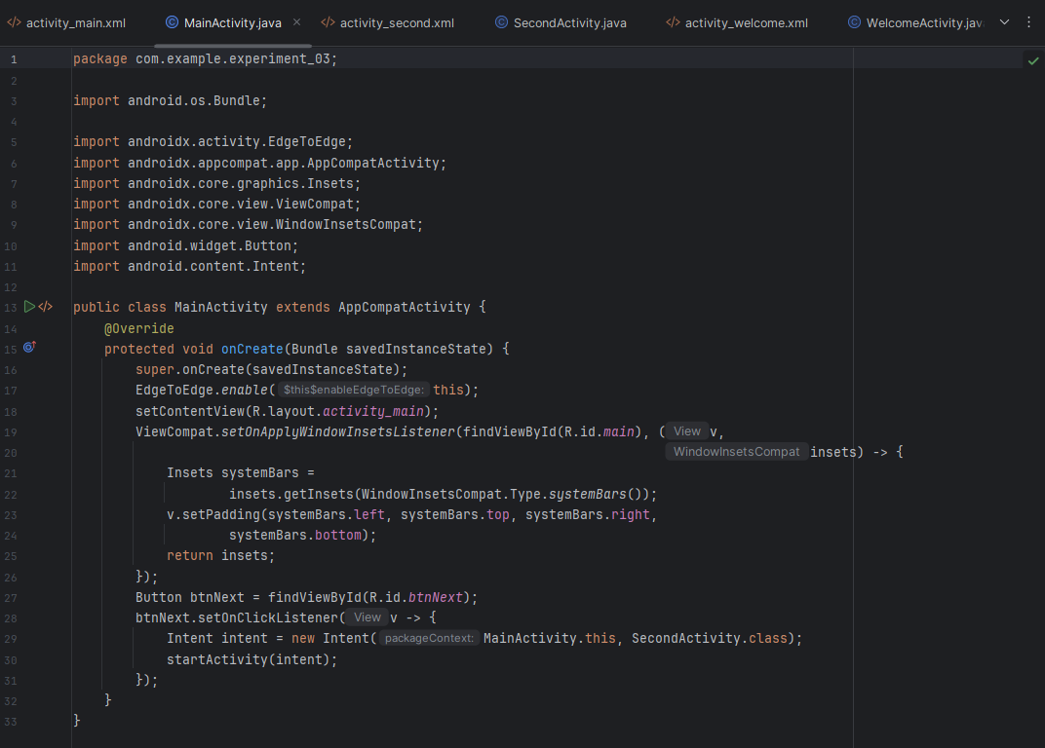

activity_second.xml
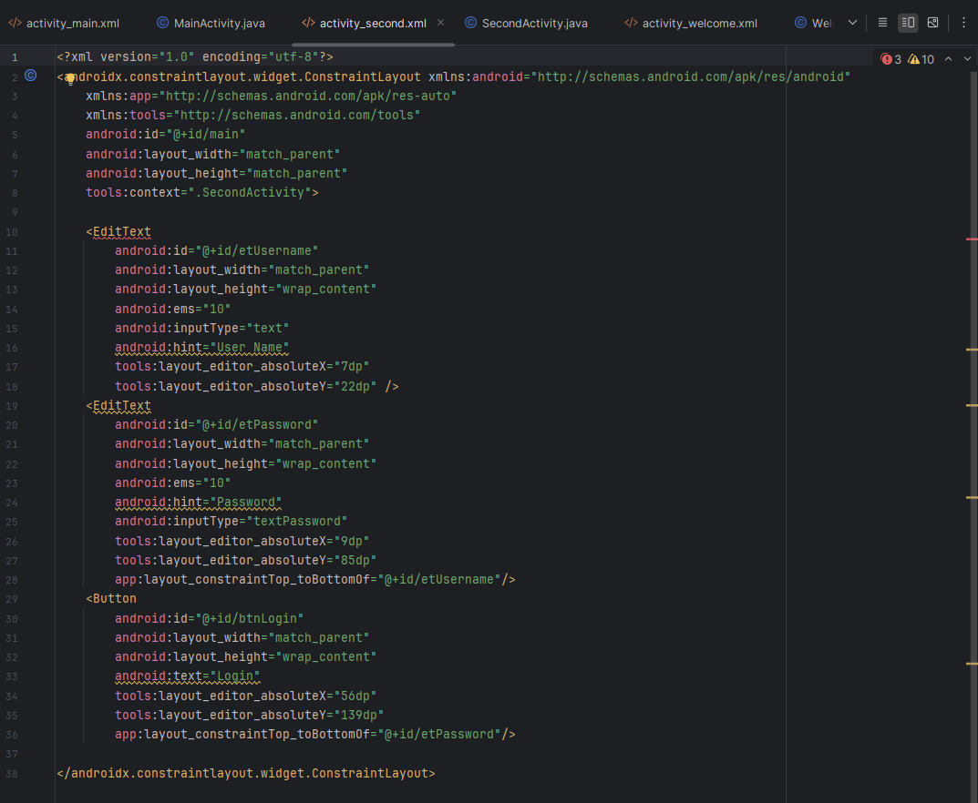

SecondActivity.java
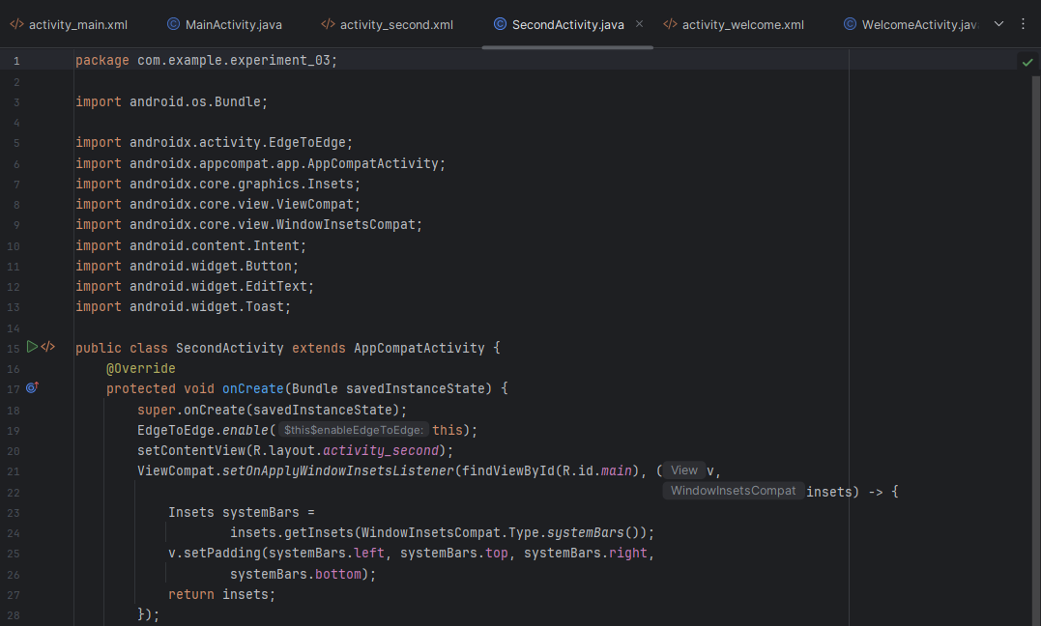
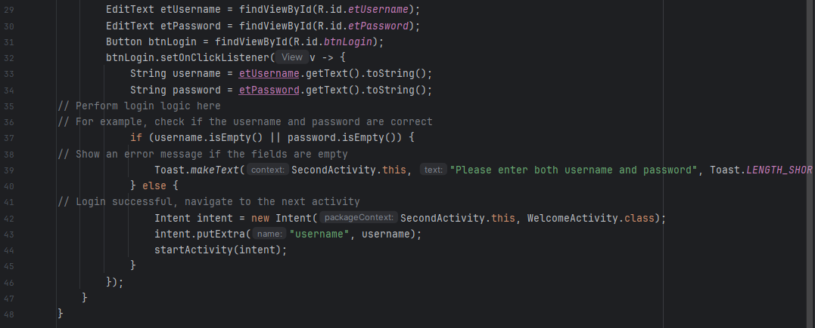

activity_welcome.xml
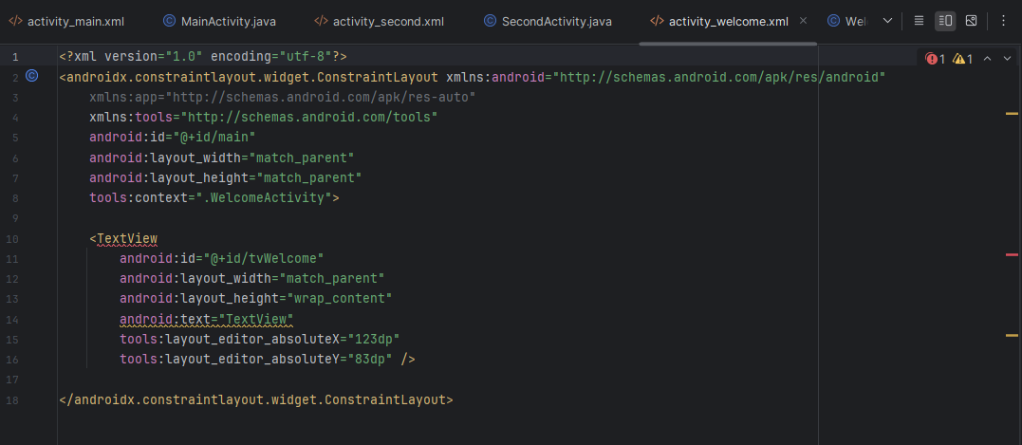

WelcomeActivity.java
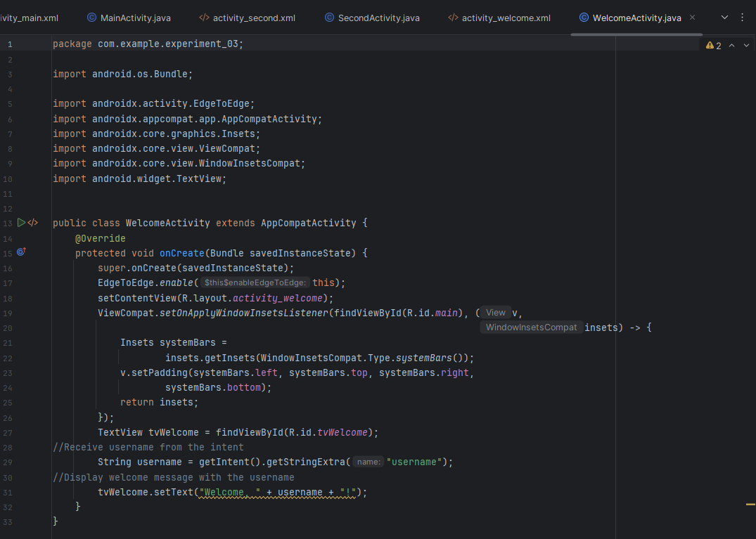

Output:
- Screen Navigation
  - Moves from:
    - Main → Second → Welcome screen using Intent
- User Input
  - User enters username and password
- Data Validation
  - If fields are empty → Toast message shown
- Data Transfer
  - Username passed between activities using:
    - putExtra() and getStringExtra()
- Dynamic Output
Final screen displays:
Welcome, [username]!

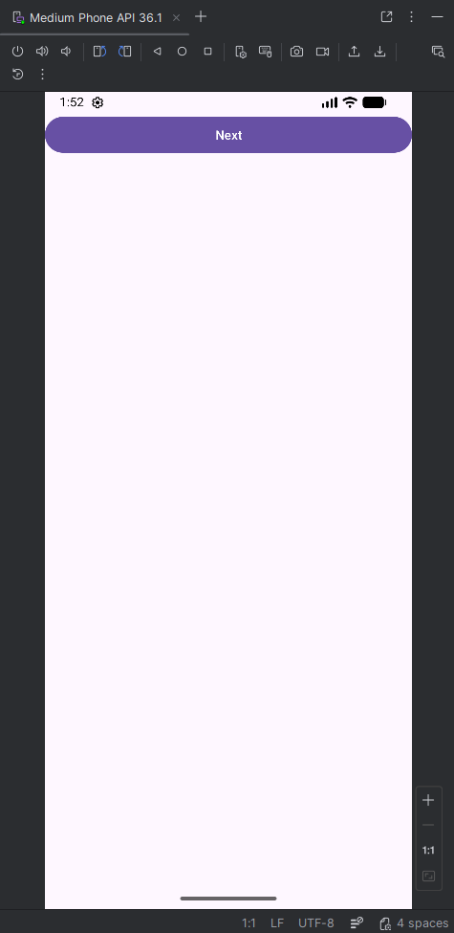 | 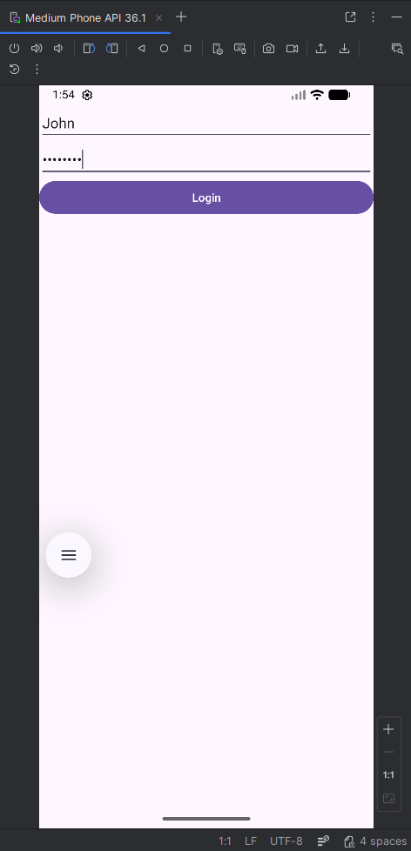 | 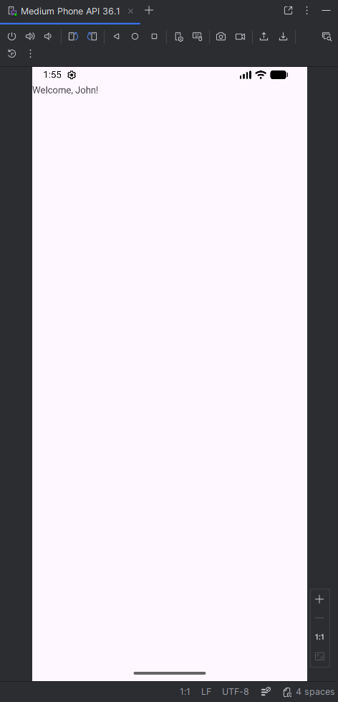

Conclusion:
This practical demonstrates how to build a basic multi-screen Android application using Android Studio. It shows how to navigate between activities using Intents, take user input, validate data, and transfer information between screens. The final output displays a personalized message, making the app interactive and dynamic.

